Task Number: Task 2
Project: House Price Prediction
Name: Gopala Vishalini
Internship: Alfido Tech

GitHub:
https://github.com/VishaliniGopala/House-price-prediction

Model File:
https://drive.google.com/file/d/1Zh2BCWH_S02BtQDVe_4yrsAS38dfC45Z/view

Screenshots:
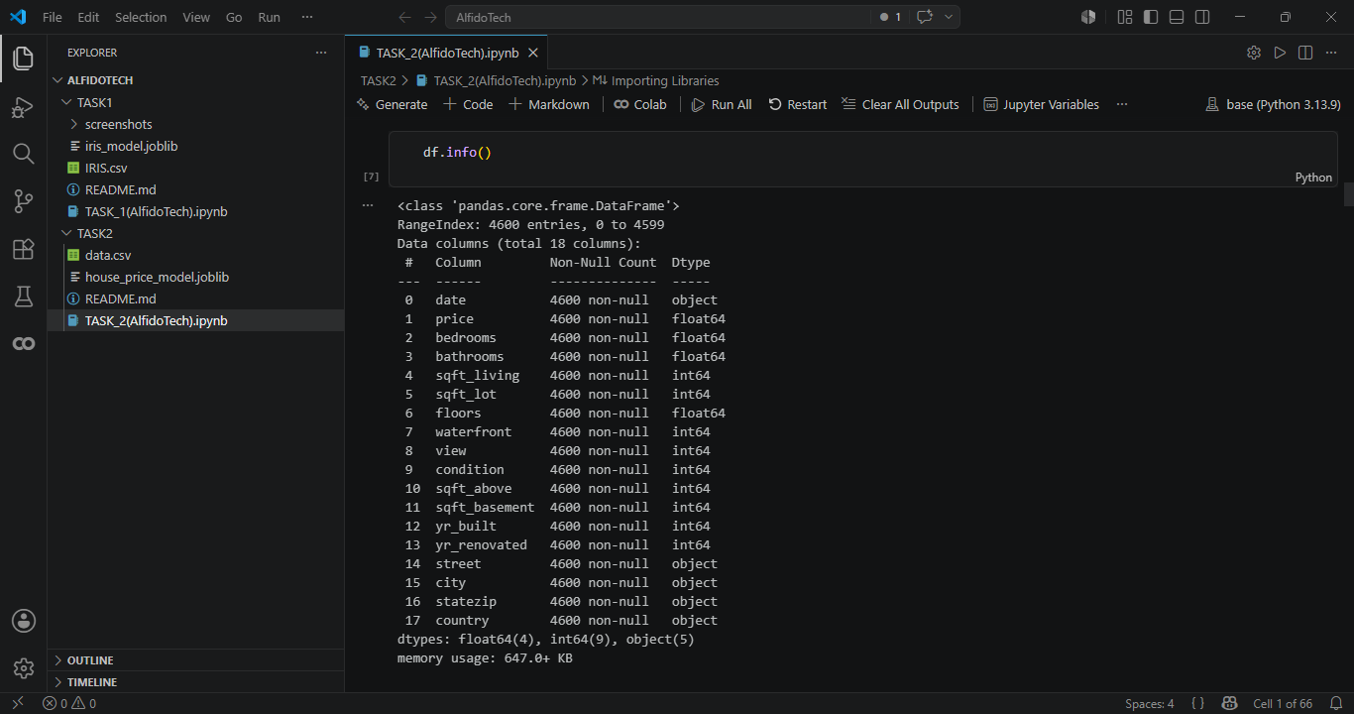
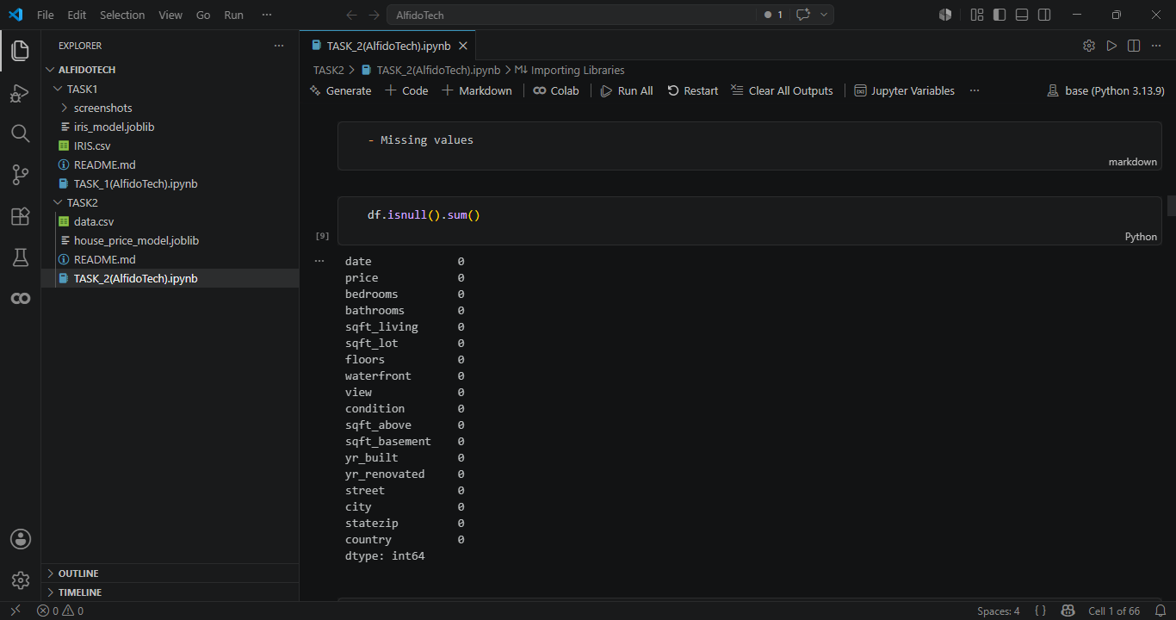
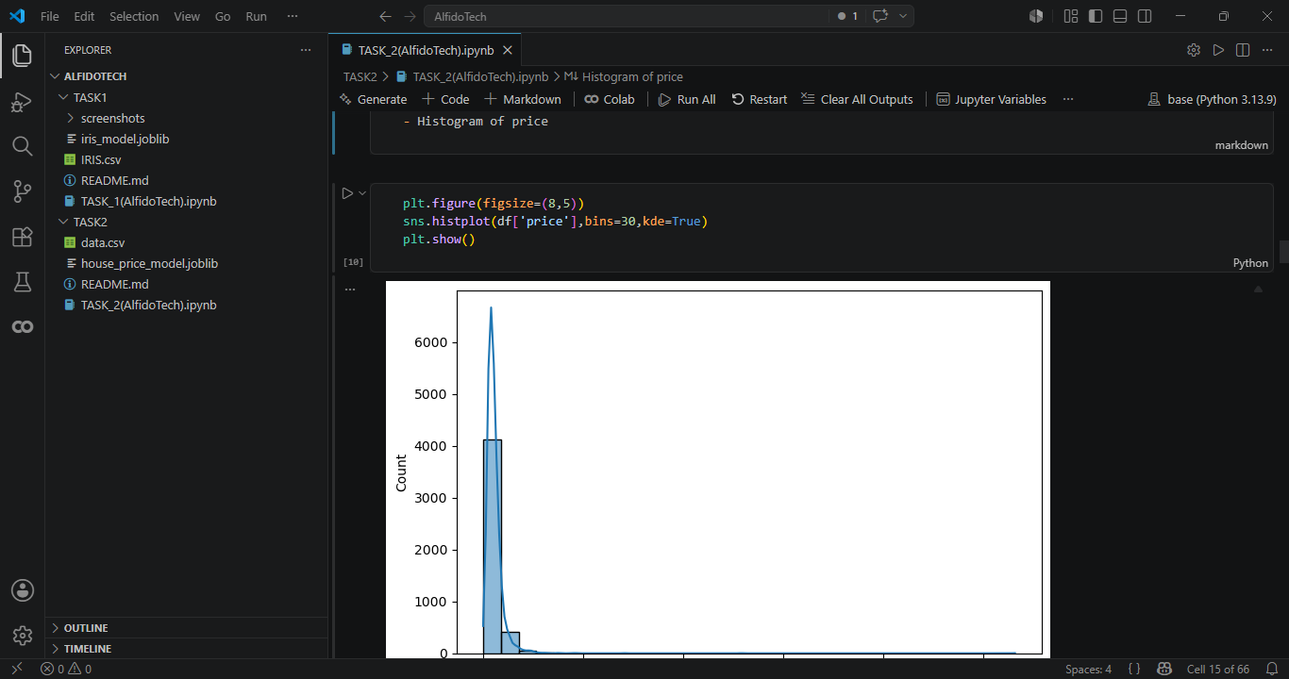
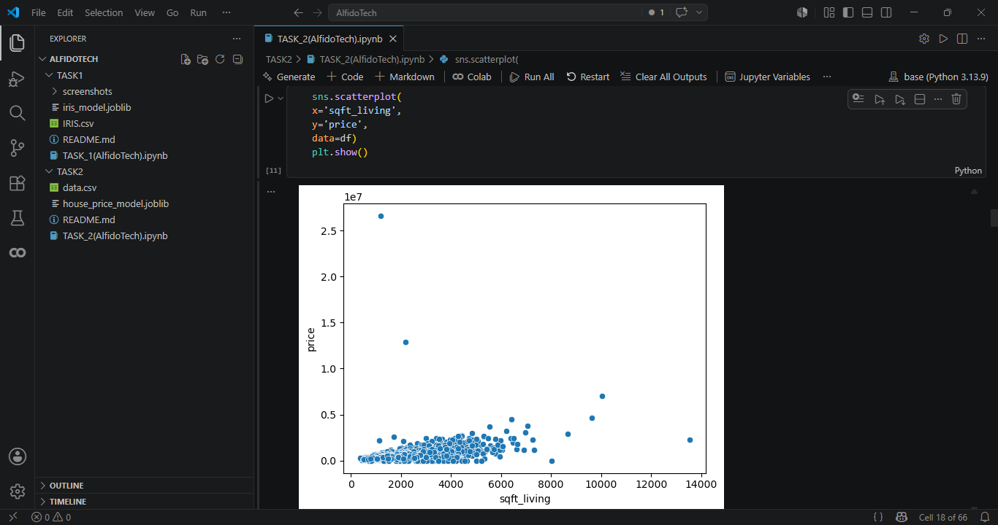
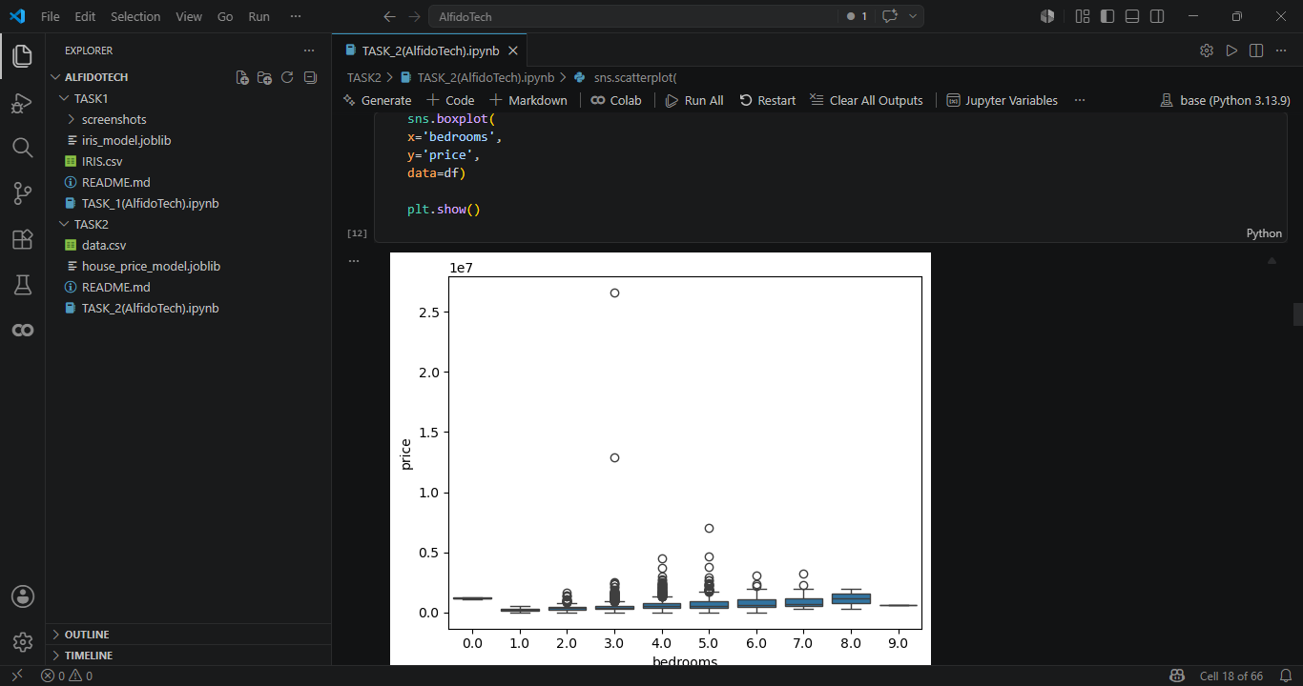
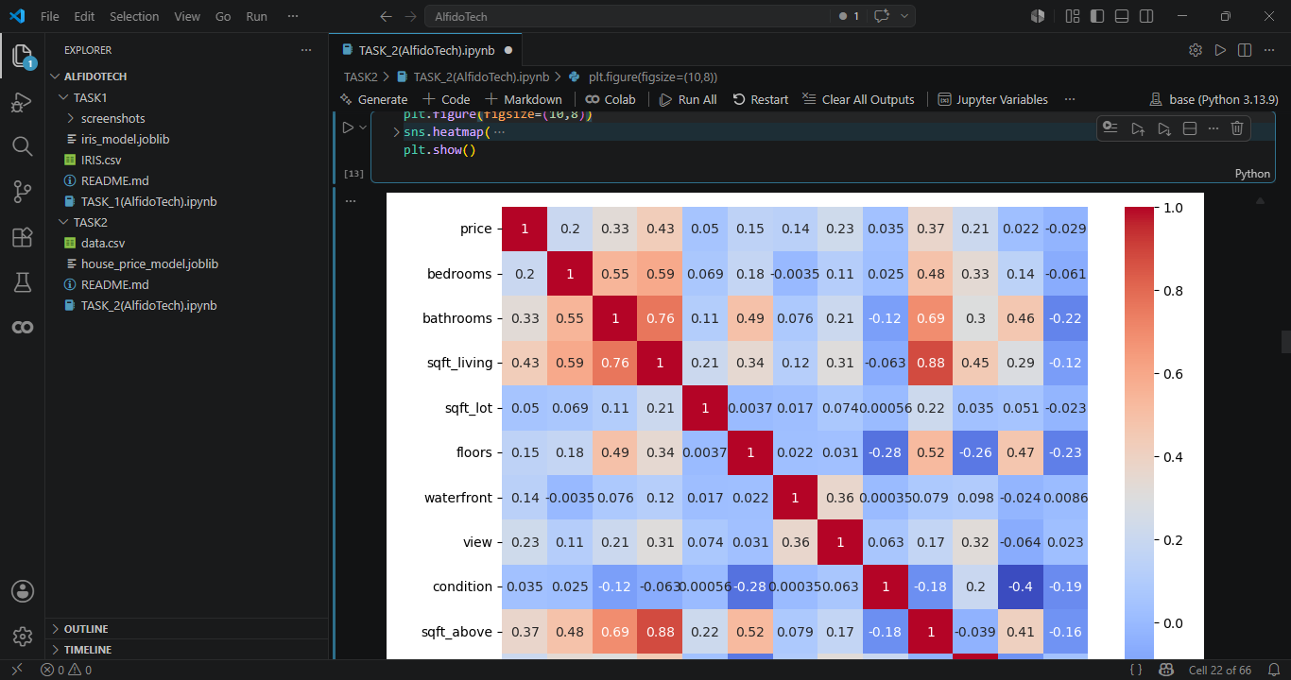
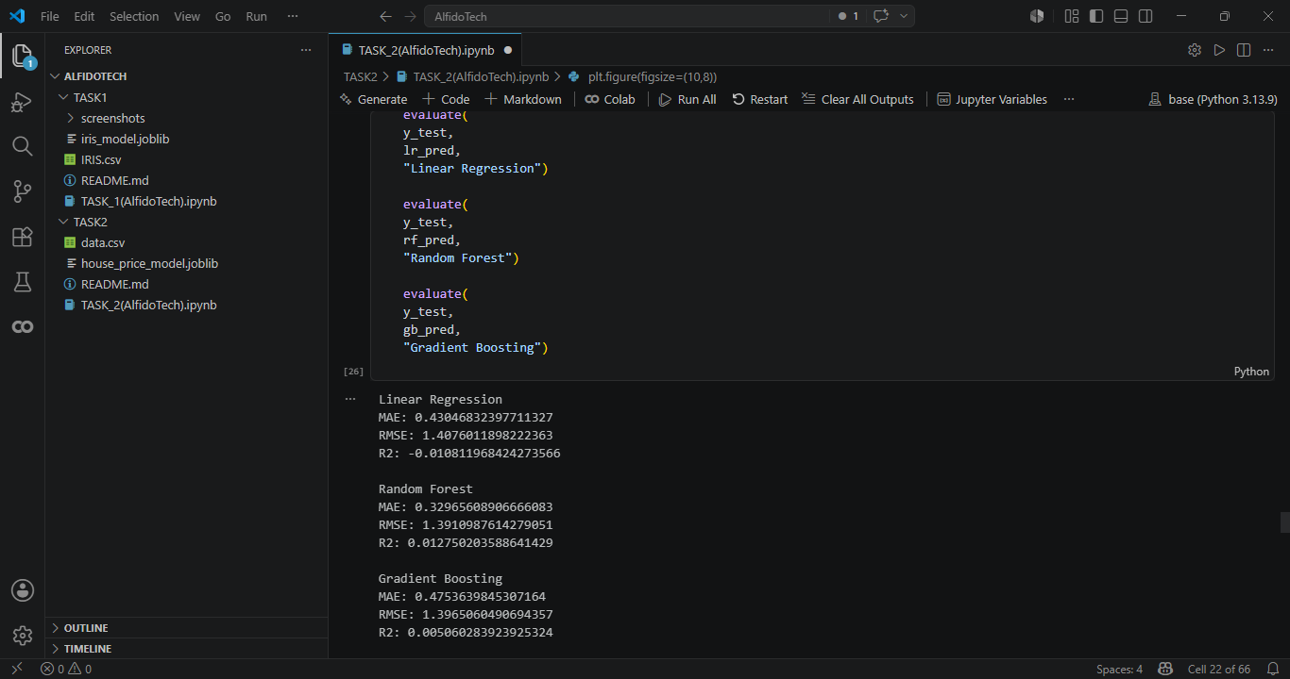
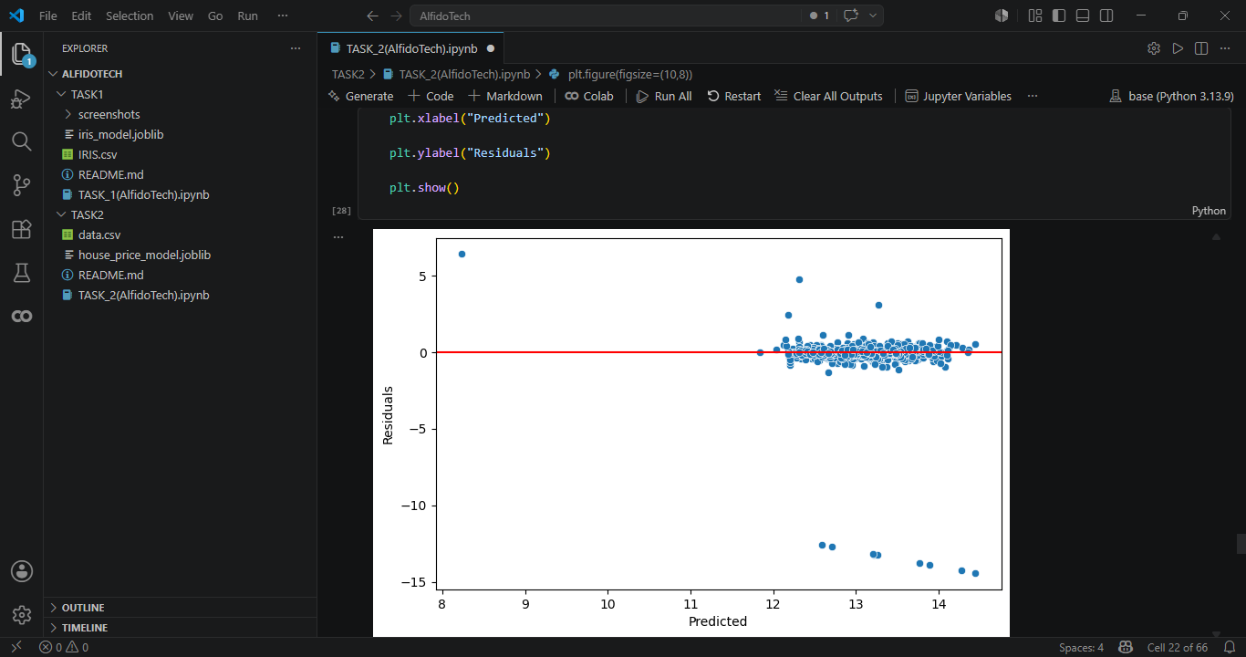
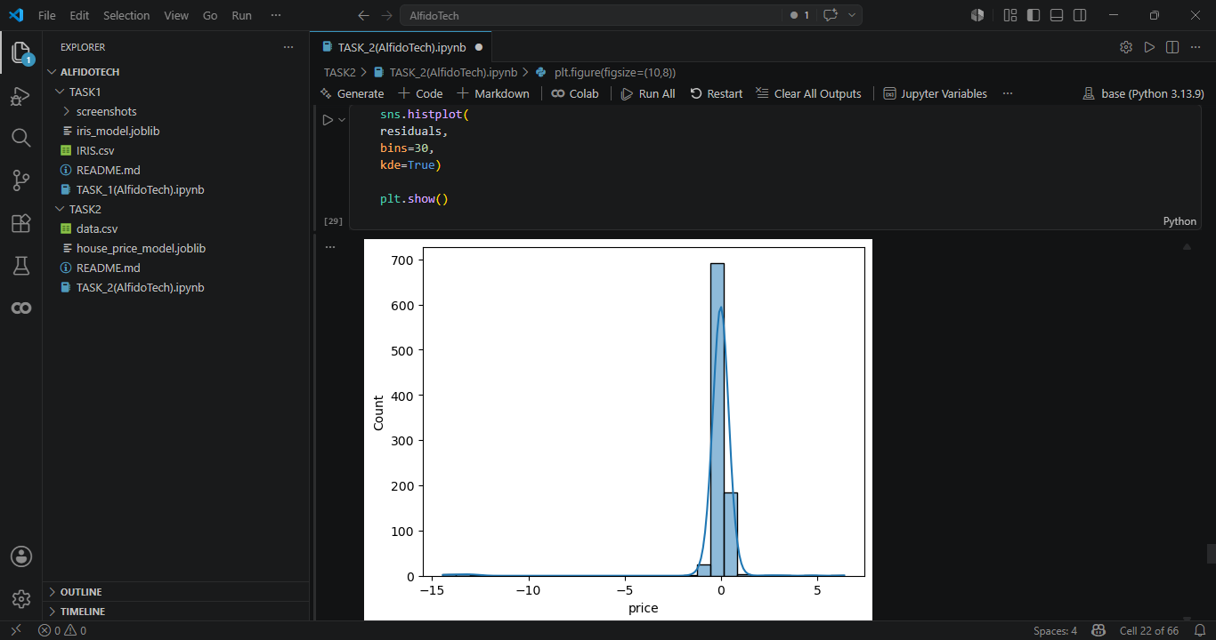
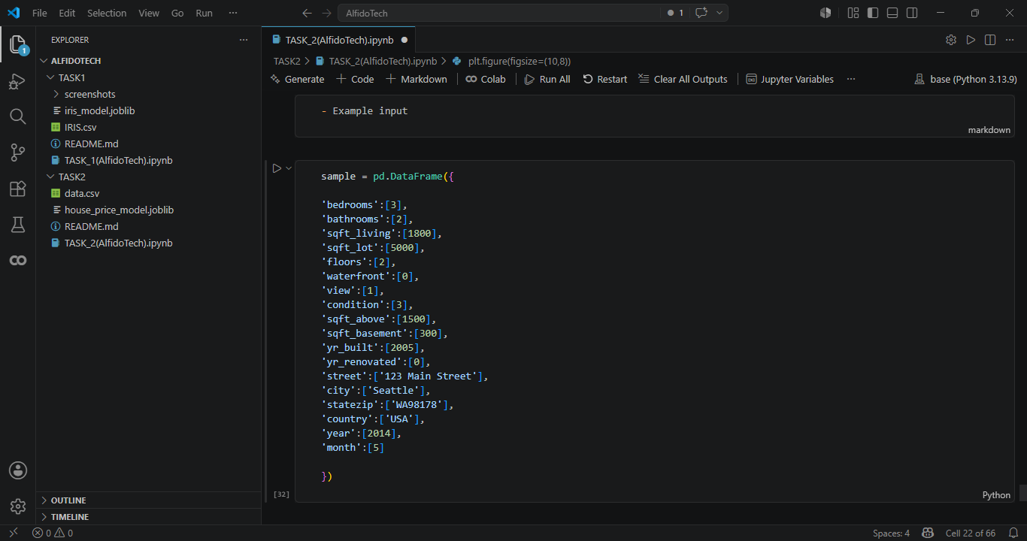
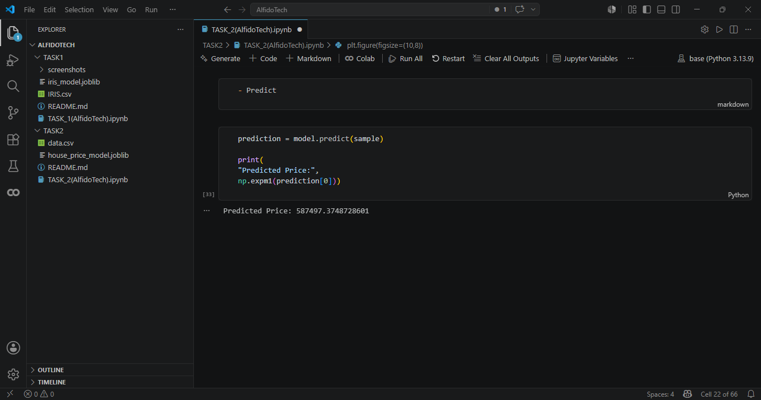
Summary — Task 2: House Price Prediction
Objective
The objective of this project was to develop a machine learning regression model to predict house prices using housing characteristics and property-related features. The dataset included attributes such as number of bedrooms, bathrooms, living area, lot size, floors, location details, construction year, and renovation information. The target variable for prediction was house price.
Methodology
The project began with Exploratory Data Analysis (EDA) to understand the dataset structure, feature distributions, and relationships between variables. Initial analysis included dataset inspection using head(), info(), describe(), and missing value analysis.
Multiple visualizations were created to explore data patterns and feature relationships, including:
- Histogram of house prices
- Scatter Plot
- Boxplot
- Correlation Heatmap
Feature engineering and preprocessing were applied to improve model performance. This included:
- Missing value handling using imputation
- Log transformation of the target variable to reduce skewness
- One-Hot Encoding for categorical variables
- Feature scaling for numerical variables
- Date feature extraction (year and month)
The dataset was then divided into training and testing sets for model development and evaluation.
Models Implemented
Three regression algorithms were trained and compared:
- Linear Regression
- Random Forest Regressor
- Gradient Boosting Regressor
These models were selected to compare linear and ensemble-based approaches for house price prediction.
Evaluation Metrics
Model performance was evaluated using regression metrics:
- MAE (Mean Absolute Error)
- RMSE (Root Mean Squared Error)
- R² Score
- Residual Analysis
Residual plots and residual distributions were used to analyze prediction errors and assess model reliability.
Results and Outcome
The implemented models successfully predicted house prices using housing features. Comparative evaluation enabled identification of the best-performing regression model based on error metrics and predictive performance. The selected model was saved using Joblib/Pickle for future use and deployment.
A prediction example was also included to demonstrate how new house information can be provided to the saved model for generating price estimates.
Technologies Used
The project was implemented using:
- Python
- Pandas
- NumPy
- Matplotlib
- Seaborn
- Scikit-Learn
- Joblib / Pickle
Conclusion
This project successfully developed a regression-based house price prediction system using preprocessing, feature engineering, model comparison, and evaluation techniques. The implementation demonstrates a complete end-to-end machine learning workflow, from data analysis to deployment-ready model saving.

